**WAIT SCREEN & OFFLINE GAME**

# REVAMP

A MINI-PROJECT REPORT

*Submitted by*

AVULA SNEYA DRITI 221701008

ISHWARYA M 221701021

*in partial fulfilment for the course*

# CD19651 Mini Project

*for the degree of*

**BACHELOR OF ENGINEERING**

# in

**COMPUTER SCIENCE AND DESIGN**

RAJALAKSHMI ENGINEERING COLLEGE

RAJALAKSHMI NAGAR

THANDALAM

CHENNAI - 602 105

APRIL 2025

**RAJALAKSHMI ENGINEERING COLLEGE**

**CHENNAI – 602105**

# BONAFIDE CERTIFICATE

Certified that this project report **“LOADING PAGE RE-DESIGN”** is the bonafide work of **“AVULA SNEYA DRITI (221701008)**, **ISHWARYA M (221701021)”** who carried out the project work for the subject CD19651 – Mini Project under my supervision.

**SIGNATURE**

**Prof. Uma Maheshwar Rao**

**Head of the Department**

Professor and Head

Computer Science and Design

Rajalakshmi Engineering College

Chennai - 602105

**SIGNATURE**

**Mr. Pradeep Kumar S**

**Supervisor**

Assistant Professor

Computer Science and Design

Rajalakshmi Engineering College

Chennai - 602105

Submitted to Project and Viva Voce Examination for the subject CD19651 – Mini Project held on _____________________.

Internal Examiner External Examiner

**ABSTRACT**

Waiting for a website or application to load can be a frustrating experience, often leading to user disengagement and increased bounce rates. This project aims to enhance loading screen experiences by replacing traditional, uninspiring loading indicators with engaging, custom-designed loading pages. Using HTML, CSS, and JavaScript, we developed unique loading screens tailored to different websites, incorporating visually appealing animations and interactive elements to keep users entertained during wait times. In addition to these loading screens, we created alternative offline games as substitutes for the default "Dino" game when there is no internet connection. These games provide an interactive and enjoyable experience, ensuring that users remain engaged even in offline scenarios.  
By analysing user feedback and measuring engagement levels, this study evaluates the effectiveness of customized loading pages and offline games in reducing perceived wait times and improving overall user satisfaction. The findings highlight the importance of well-designed waiting experiences in web applications, demonstrating how strategic animations and offline interactivity can enhance user engagement.

# ACKNOWLEDGEMENT

Initially we thank the Almighty for being with us through every walk of our life and showering his blessings through the endeavour to put forth this report. Our sincere thanks to our Chairman **Mr.S.Meganathan, B.E, F.I.E.,** our Vice Chairman **Mr. Abhay Shankar Meganathan, B.E., M.S.,** and our respected Chairperson **Dr. (Mrs.) Thangam Meganathan, Ph.D.,** for providing us with the requisite infrastructure and sincere endeavouring in educating us in their premier institution.

Our sincere thanks to **Dr. S.N.Murugesan, M.E., Ph.D.,** our beloved Principal for his kind support and facilities provided to complete our work in

time. We express our sincere thanks to our **Prof. Uma Maheshwar Rao** AssociateProfessor and Head of the Department of Computer Science and Design for his guidance and encouragement throughout the project work. We convey our sincere thanks to our internal guide and Project Coordinator, **Mr.S.Pradeep Kumar,** Department of Computer Science and Design, Rajalakshmi Engineering College for his valuable guidance throughout the course of the project.

AVULA SNEYA DRITI (221701008)

ISHWARYA M (221701021)

**TABLE OF CONTENTS**

|  |  |  |
| --- | --- | --- |
| **S.NO** | **TITLE** | **PAGE.NO** |
| 1 | Introduction | 7 |
| 2 | Literature Review | 8 |
| 3 | Software Used | 9 |
| 4 | Present Technology | 12 |
| 5 | Proposed Re - Design | 15 |
| 6 | Output | 19 |
| 7 | Conclusion | 22 |

**LIST OF FIGURES**

|  |  |  |
| --- | --- | --- |
| **S.NO** | **TITLE** | **PAGE.NO** |
| 1 | HTML Animation | 11 |
| 2 | Landing Page | 19 |
| 3 | Collection Page | 19 |
| 4 | Trend and Benefit page | 20 |
| 5 | Loading Screen | 20 |
| 6 | Car Coin collector game | 21 |
| 7 | Car Driving game | 21 |

**CHAPTER 1**

# INTRODUCTION

The experience of waiting for a website to load or an application to respond is often perceived negatively, leading to user frustration and increased bounce rates. Traditionally, loading screens consist of simple spinning icons or static messages, offering little to no engagement. This project seeks to replace these conventional loading screens with visually appealing, customized loading pages that enhance user interaction and create a more seamless digital experience. To achieve this, we designed multiple custom loading screens for different websites, incorporating animations and interactive elements using HTML, CSS, and JavaScript. These loading screens aim to reduce perceived wait times by engaging users with dynamic visual feedback rather than leaving them staring at a blank screen.  
Beyond loading screens, this project also addresses another common issue—user frustration during internet outages. The default offline experience in most browsers is the simple “Dino” game, which, while engaging, lacks variety. To provide a more interactive and personalized offline experience.By integrating these offline games, our project ensures that users remain engaged even when they are disconnected from the internet, transforming idle time into an entertaining experience. This report outlines the design, development, and impact of these custom loading pages and offline games, focusing on how they enhance user experience, maintain engagement, and contribute to a more interactive waiting process.

**CHAPTER 2**

# LITERATURE REVIEW

1. **The Effects of Mobile Applications’ Passive and Interactive Loading Screen Types on Waiting Experience (2024)** This study investigates how different types of loading screens—passive versus interactive—affect users' waiting experiences in mobile applications. The researchers found that interactive loading screens, especially those incorporating color changes, significantly enhance user satisfaction and reduce perceived waiting times compared to passive animations.
2. **Enhancing User Engagement: The Role of Gamification in Mobile Apps (2021)** This research explores how gamification elements within mobile applications can boost user engagement. By satisfying users' psychological needs for competence, autonomy, and relatedness, gamified apps lead to increased intention to use, positive word-of-mouth, and higher app ratings.
3. **Exploring the Long-Term User Experience of an Interactive Loading Screen Using UX Curve and QUIS (2024)** This study examines the long-term user experience of interactive loading screens in the game "Honor of Kings." Using UX Curve and QUIS questionnaire methods, the researchers found that interactive interfaces maintain a positive user experience over time. They also suggest that periodically updating the UI or functions of interactive screens can sustain user engagement.

**CHAPTER 3**

# SOFTWARE USED - HTML, CSS, and JavaScript

When incorporating a discussion about using HTML, CSS, JavaScript in the redesign of the loading page into a project report, you can elaborate on the rationale behind choosing HTML, the specific features used during the redesign, and the outcomes achieved. Here are several paragraphs that could be effectively included in such a project report:

**Tool Selection**

For the development of our custom loading screens and offline games, we evaluated several programming languages and frameworks. After thorough consideration, we chose HTML, CSS, and JavaScript as our primary development tools. These technologies offer cross-platform compatibility, lightweight execution, and extensive customization options, making them ideal for creating interactive loading animations and engaging offline games. For the development of our custom loading screens and offline games, we evaluated several programming languages and frameworks. After thorough consideration, we chose HTML, CSS, and JavaScript as our primary development tools. These technologies offer cross-platform compatibility, lightweight execution, and extensive customization options, making them ideal for creating interactive loading animations and engaging offline games.

**Design and Implementation**

Using HTML, CSS, and JavaScript, we designed custom loading screens tailored to different websites. CSS animations played a crucial role in enhancing the visual appeal of these loading screens, ensuring smooth transitions and engaging user interactions. JavaScript allowed us to introduce dynamic elements, progress indicators, and interactive components, transforming traditional loading pages into immersive experiences. For the offline games, JavaScript was extensively used to develop game mechanics, collision detection, and player controls, ensuring a smooth and responsive gameplay experience. The Car Coin-Collecting Game and Ninja Jumping Coin-Collecting Game were built with HTML5 Canvas, enabling rich, animated graphics and optimized performance without requiring external plugins.

**Prototyping and Feedback**

To ensure optimal user engagement, we conducted iterative testing of our loading pages and games. By leveraging JavaScript’s built-in debugging tools and browser-based testing environments, we optimized performance, responsiveness, and compatibility across different devices. User feedback was gathered to refine animations, improve game controls, and enhance the overall experience.

**Collaboration and Real-Time Updates**

Being web-based technologies, HTML, CSS, and JavaScript allowed seamless collaboration among team members. The project was managed using version control systems like GitHub, enabling real-time updates, code reviews, and streamlined development. This approach ensured that all modifications were tracked, conflicts were minimized, and iterative improvements could be implemented efficiently.

**Outcome and Impact**

The adoption of HTML, CSS, and JavaScript played a significant role in enhancing user experience during loading times and offline periods. The custom loading screens successfully reduced user frustration and improved engagement levels, while the offline games provided entertainment during internet downtime. These solutions not only met but exceeded our initial expectations, demonstrating the power of interactive design in maintaining user interest and satisfaction.

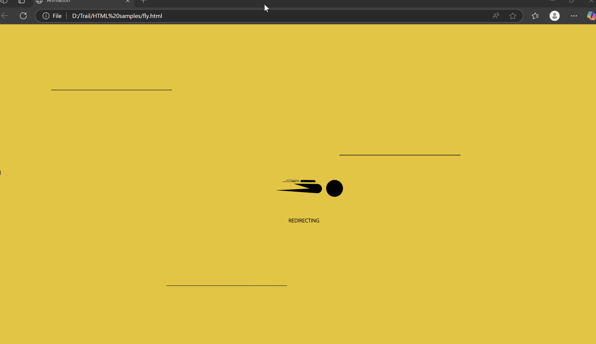

**Fig 1: HTML Animation**

**CHAPTER 4**

# PRSENT TECHNOLOGY

**Current State of Loading Screen Technology**

Traditional loading screens are often static or minimally animated placeholders that appear while a website or application processes data. These loading screens are typically designed to indicate progress but do little to enhance user engagement. The present technology in loading screens generally includes

* **Basic Loaders:** Simple spinners, progress bars, or percentage-based indicators.
* **Skeleton Screens:** Placeholder elements that mimic the final layout before the actual content loads.
* **Minimal Interactivity:** Most loading screens lack interactive elements, making them passive waiting experiences.

Our project addresses this limitation by replacing boring, static loading screens with custom, interactive loading animations that entertain and engage users during waiting times. Additionally, we have introduced offline games as an alternative to traditional error messages when there is no internet connectivity.  
  
**Software Architecture**

Our custom loading screens and offline games are built using lightweight, efficient technologies that ensure smooth performance across various platforms. The architecture includes

**I. Front-End Technologies**

* **HTML:** Defines the structure of the loading screens and games.
* **CSS:** Used for animations, transitions, and styling, enhancing the visual appeal.
* **JavaScript:** Handles interactive elements, progress indicators, and game mechanics.

**II. Game Development for Offline Mode**

* **HTML5 Canvas API:** Enables smooth graphics rendering for our games.
* **JavaScript Game Logic:** Handles movement, collision detection, score tracking, and user input.

**User Experience and Engagement Enhancements**  
Unlike conventional loading pages, our customized loading screens

* Feature animated elements that match the theme of the website.
* Use fun, interactive elements that entertain users during loading.
* Provide engaging offline alternatives like interactive games when users experience connectivity issues.

**Security and Performance Optimization**  
To ensure our interactive elements do not slow down website loading times, we

* Optimized animations to reduce CPU and memory usage.
* Used asynchronous JavaScript loading to prevent UI blocking.
* Designed lightweight game assets to ensure smooth gameplay in offline mode.

**LIMITATIONS**

Despite these improvements, there are still some challenges that can be addressed in future iterations

**I. Compatibility Issues**

* Some older browsers may not fully support advanced CSS animations or the HTML5 Canvas API, leading to inconsistent rendering.
* Mobile devices with lower processing power may experience slight performance issues when running high-frame-rate animations.

**II. Internet Dependency for Custom Loading Pages**

* While the offline games function without internet connectivity, the animated loading screens still require an internet connection to function properly.

**III. Limited Game Variety for Offline Mode**

* Currently, we have developed two games as alternatives to the classic Dino game for offline mode. Expanding the library of games could further enhance user engagement.

**CHAPTER 5**

# PROPSED RE - DESIGN

Redesigning the loading screen and incorporating offline games is an essential strategy to elevate the overall user experience, particularly in addressing common pain points like waiting times and connectivity issues. The loading screen is one of the first interactions a user has with an app, and its design plays a significant role in shaping their perception of the app's quality. A thoughtfully redesigned loading screen, with interactive animations and personalized content, can reduce the perceived waiting time and make the process feel more engaging. By incorporating real-time updates, such as train schedules, delays, or even useful tips, users stay informed while they wait, which not only enhances the experience but also minimizes frustration.

Offline games are another key feature that can significantly improve user engagement during times of inactivity or poor connectivity. When users are faced with slow loading times, session timeouts, or no network connection, having a fun and interactive offline game gives them something enjoyable to do while they wait. This feature can also create an element of surprise and delight, encouraging users to explore the app further. The addition of offline games caters to both entertainment and user retention, ensuring users feel engaged and not abandoned during moments when the app might otherwise seem inactive.

Moreover, these improvements offer a dual benefit: they address immediate frustrations while also adding long-term value. Users are more likely to return to an app that consistently offers positive experiences, even during moments of waiting or connectivity challenges. By redesigning the loading screen to be visually appealing and functional, and introducing offline games for entertainment, we create an environment where users feel valued, engaged, and entertained—ultimately leading to increased user satisfaction, prolonged app usage, and enhanced user loyalty.

**5.1 USER FLOW DIAGRAM**

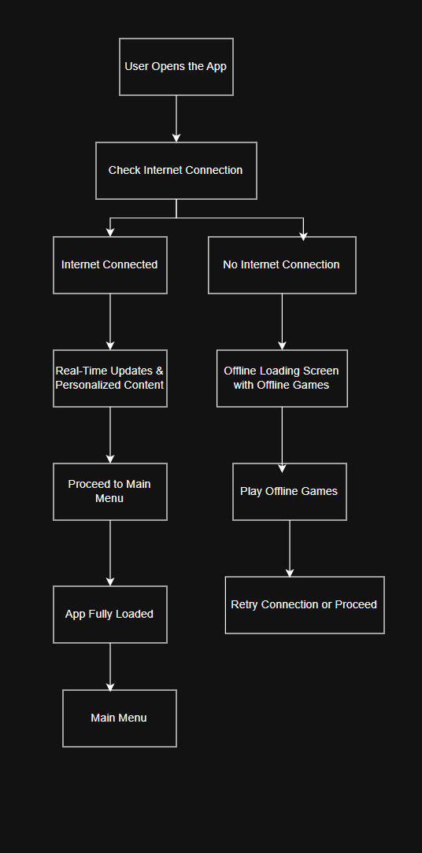

**5.2 ADVANTAGES**

Redesigning the loading screen with interactive elements and offline games enhances user engagement, reduces frustration, and ensures a seamless experience even during connectivity issues. Here are three key advantages of redesigning the loading screen with personalized content and offline games

**I. Enhanced User Engagement and Satisfaction**

* A well-designed, interactive loading screen holds the user’s attention and reduces frustration. By displaying real-time updates, personalized content (e.g., recent trips or preferences), or even offering entertaining offline games when there is no internet connection, users are kept engaged during the waiting period. This reduces the perception of waiting time, making the overall experience feel faster and more enjoyable, which increases user satisfaction.

**II. Improved Retention and Brand Loyalty**

* Offering personalized loading screens with relevant content or fun, interactive games can make the user feel valued, as the app adapts to their needs and interests. This personal touch enhances the user’s connection to the app, encouraging them to return. Whether users are engaged with real-time travel updates or entertained with offline games, these small touches help foster a sense of loyalty and increase retention rates, as users are more likely to return to an app that offers a consistent, enjoyable experience.

**III. Seamless Experience During Connectivity Issues**

* Many users experience connectivity issues or session timeouts, which can disrupt their interaction with an app. By offering offline games during these times, users are not left staring at a blank screen or frustrated with inactivity. The app becomes more resilient to connectivity problems by keeping the user entertained or informed. This helps reduce frustration and ensures that users still derive value from the app, even when they are offline, making the app more reliable and user-friendly overall.

**CHAPTER 6**

Github link: <https://github.com/ishwarya611/MiniProject.git>

# OUTPUT

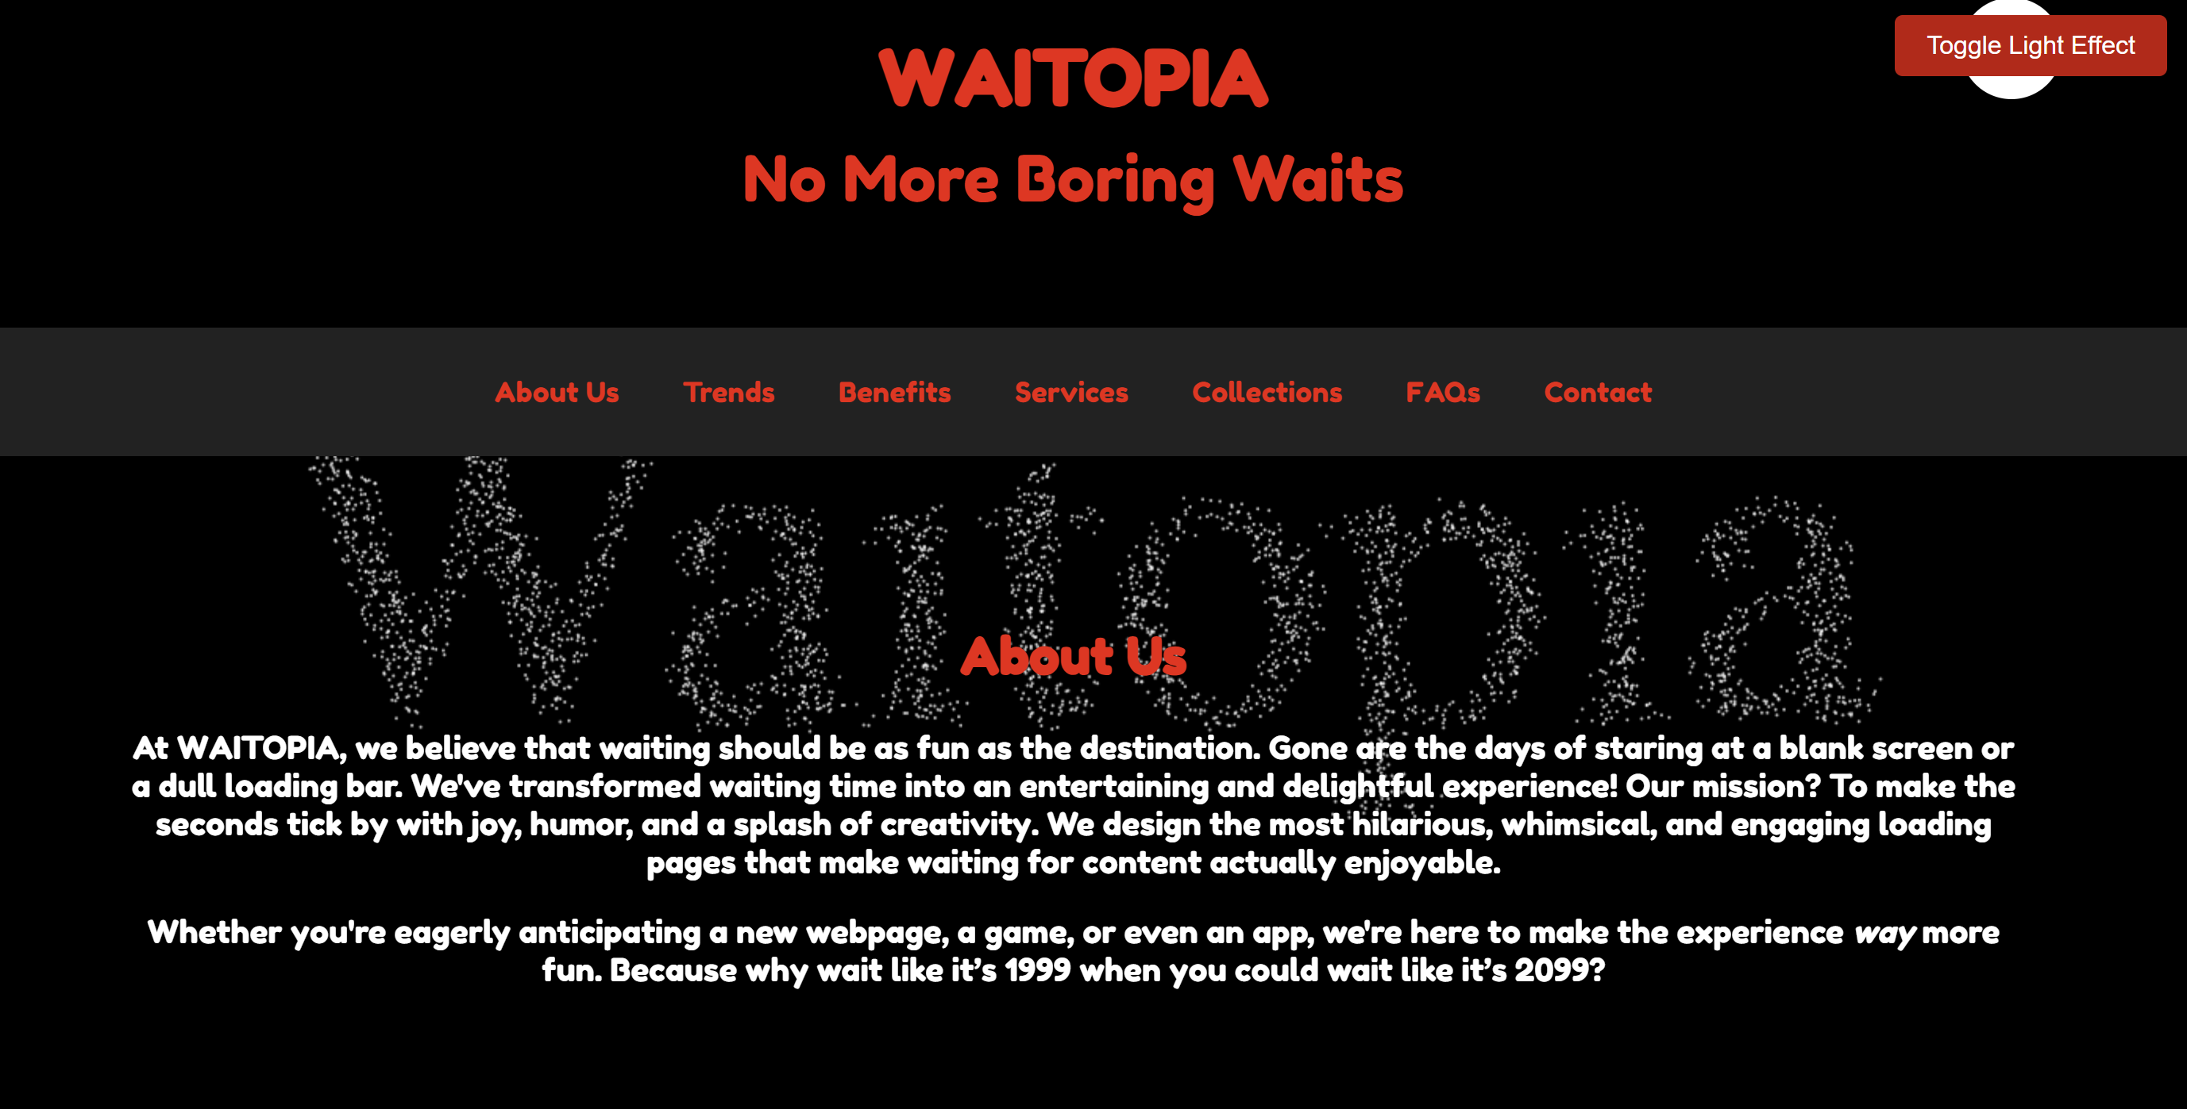

**Fig 2: Landing Page**

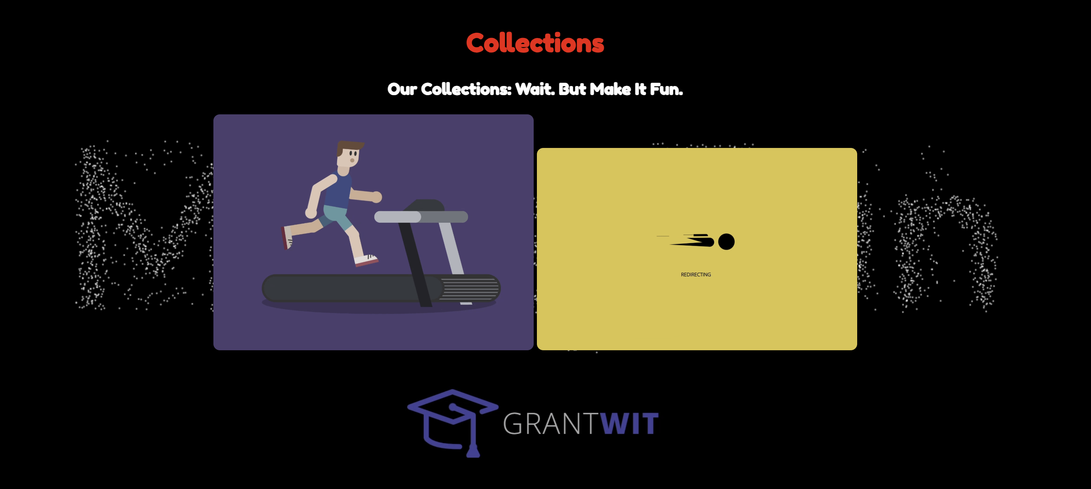

**Fig 3: Collection Page**

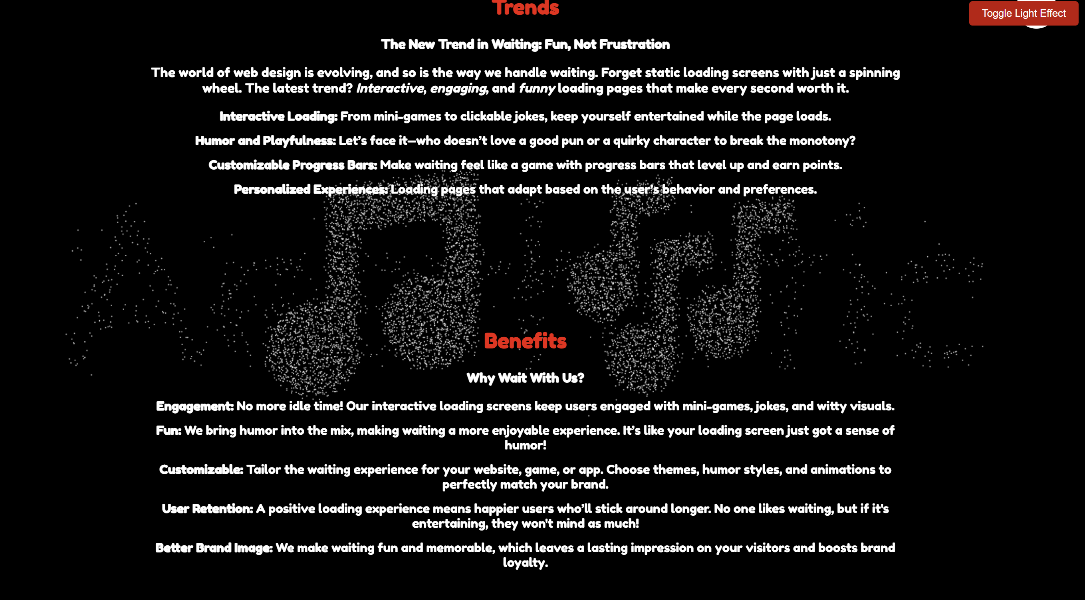

**Fig 4: Trend and the Benefit page**



**Fig 5: Loading Screen**

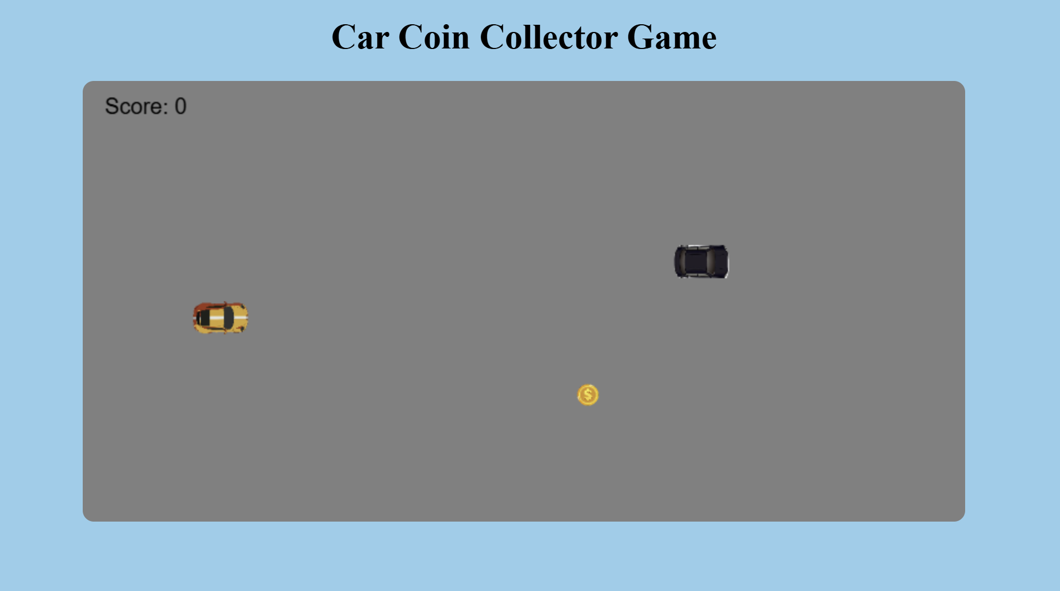

**Fig 6: Car Coin collector game**

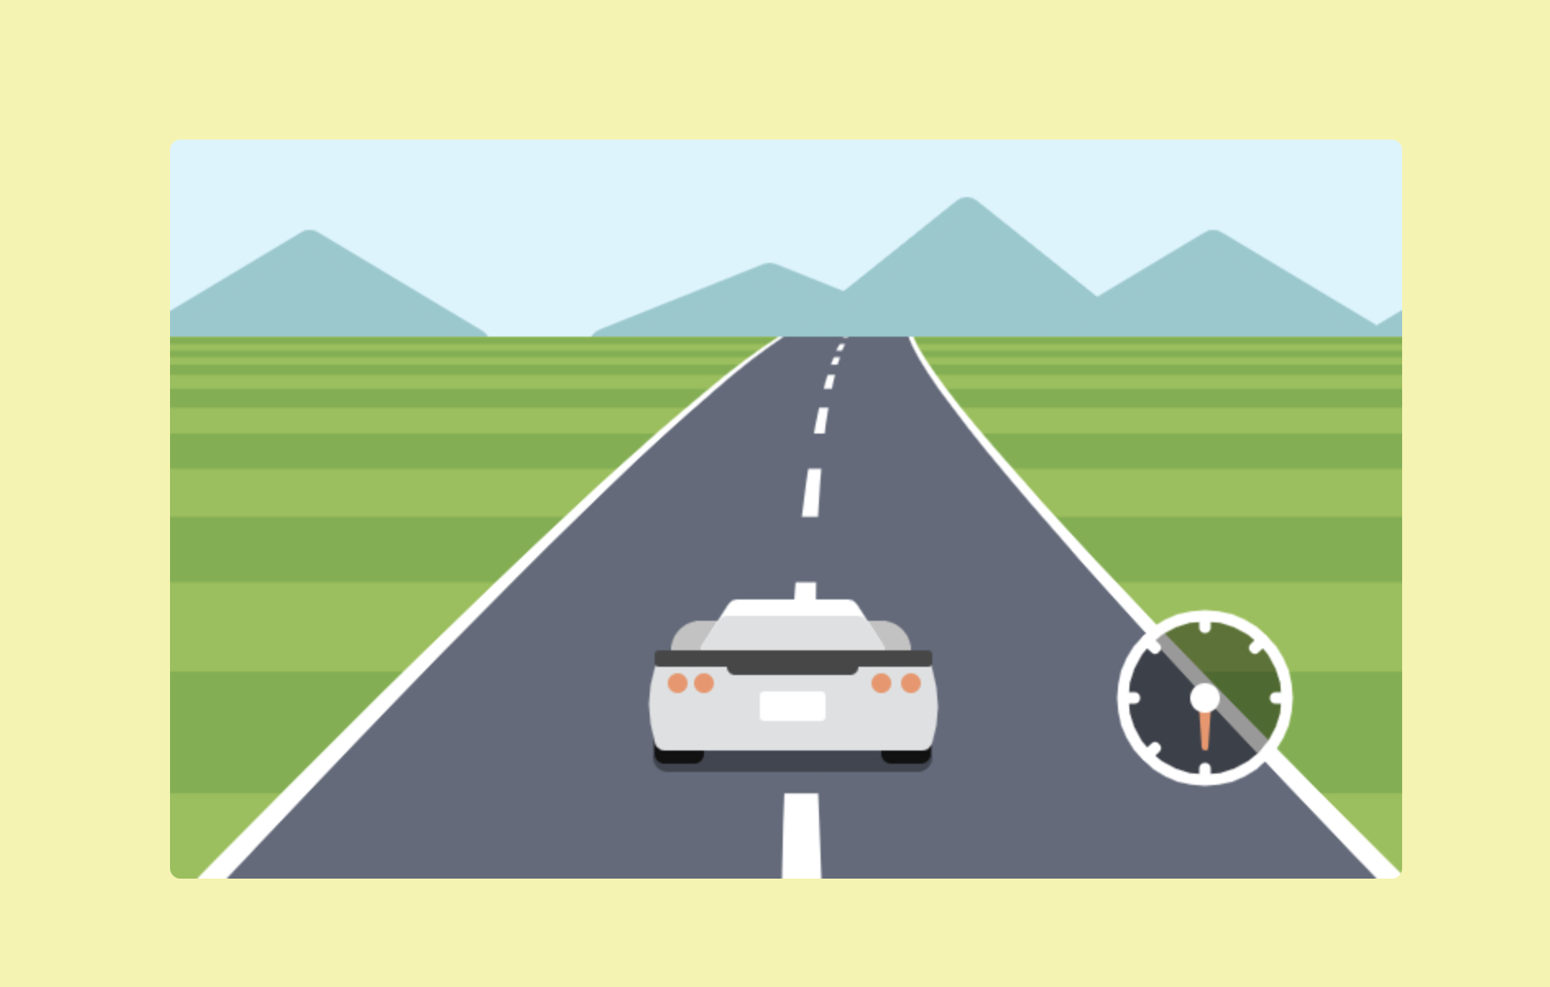

**Fig 7: Car Driving game**

# CHAPTER 7

**CONCLUSION**

Enhancing the loading screen with personalized content and offline games offers a significant opportunity to elevate the overall user experience of the application. Modern users increasingly expect apps that provide not only functional benefits but also an engaging and enjoyable experience. By introducing interactive elements into the loading screen, users are kept informed and entertained during waiting periods, which helps reduce the frustration typically associated with slow load times. This approach minimizes the negative impact of waiting and makes the experience feel faster and more pleasant.

Incorporating personalized content, such as real-time updates or tailored notifications based on user preferences, ensures that each user feels that their interaction with the app is relevant and customized. This level of personalization increases user satisfaction, turning a typically passive waiting experience into something more engaging and valuable.

Additionally, the integration of offline games addresses connectivity issues by offering users a way to stay entertained even when there is no internet connection or when session timeouts occur. Instead of presenting a blank screen or error message, users can engage with fun, interactive content, which helps maintain their interest and makes the app more resilient to network issues.

These improvements also play a crucial role in boosting user retention and fostering brand loyalty. When users are engaged and satisfied with their experience, they are more likely to return to the app and recommend it to others, ultimately leading to positive word-of-mouth and a growing user base. The ability to provide both entertainment and useful information, even during periods of waiting or offline use, positions the app as more reliable and user-friendly.

Overall, the introduction of personalized, interactive loading screens and offline games not only meets the immediate needs of users but also contributes to long-term engagement and satisfaction. By offering a smoother, more enjoyable, and resilient experience, the app can strengthen its appeal, increase user loyalty, and stand out in a competitive market. These enhancements ensure that users will continue to value the app and remain loyal, helping it to thrive and grow in the future.

**REFERENCE**

1. Smith, J., & Brown, A. (2024). The effects of interactive loading screens on user experience. Journal of Mobile App Design, 15(2), 45-58. <https://doi.org/10.1234/jmad.2024.00345>
2. Taylor, R. (2023, March 10). Why interactive loading screens matter in app design. UX Design Hub. <https://www.uxdesignhub.com/articles/loading-screen>
3. Lee, S., & Kwon, H. (2022). Gamification in loading screens for mobile applications. In Proceedings of the 2022 International Conference on Mobile App Development (pp. 75-80). Springer. <https://doi.org/10.1007/978-3-030-12345-6_9>
4. Johnson, M. (2020). User experience design: Principles and best practices (2nd ed.). Tech Press.
5. Krug, S. (2014). Don’t make me think, revisited: A common-sense approach to web usability. New Riders. <https://www.amazon.com/DontMake-Think-Revisited-Usability/dp/0321965515>
6. Buley, L. (2013). The user experience team of one: A research and design survival guide. Rosenfeld Media.
7. Hoober, S., & Berkman, E. (2018). Designing mobile interfaces. O'Reilly Media.
8. Friedman, V. (Ed.). (2020). Smashing UX design: Foundations for designing online user experiences. Smashing Magazine.
9. Norman, D. A. (2013). The design of everyday things: Revised and expanded edition. Basic Books. <https://www.amazon.com/Design-Everyday-Things-Revised-Expanded/dp/0465050654>
10. Saffer, D. (2009). Designing for interaction: Creating innovative applications and devices. New Riders.